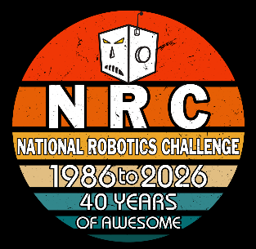


ARC Engineering Notebook
National Robotics Challenge 2026 – Micromouse Contest
Post Secondary – Southern Illinois University Edwardsville

Table of Contents
Meet the Team 2
Background 2
Attending Members 2
Faculty 4
Additional Club Members 4
Mechanical and CAD 5
Motor Choice 6
Chassis and Mounts 6
Final Design 7
Electrical 9
Controller Boards 9
Sensors 10
Wiring 11
Programming 13
Maze Solving Algorithm 13
Communication and Commands 14
Iterations and Lifecycle 18
Early Iterations and Beginnings 18
First Iteration and Testing 19
Second Iteration and Setbacks 20
Multiple Teams – Multiple Robots 20
Final Decisions and Remarks 23
Club Meeting Summaries 24

MEET THE TEAM
BACKGROUND
The Autonomous Robotics Club (ARC for short) aims to provide students with opportunities to expand upon their class concepts through hands-on projects, working towards both internal and national competitions to help apply a variety of engineering skills. Members enjoy a collaborative environment where multiple engineering disciplines come together, learning more about what it takes to build robots from the ground up and what kinds of systems and design to consider while making use of the tools and other resources provided by the School of Engineering.
Spanning the diverse subject of autonomous robotics, ARC aims to give students the confidence they need to develop and polish essential engineering skills such as CAD, software development, and circuit design, which is further enhanced by the wide variety of engineering fields that our membership covers. Through preparation for competitions, students will get a feel for working in teams to teach and learn from each other, expanding upon both leadership and considerate planning to achieve a common goal. Whether engineering student or not, our club strives to give any member the ability to enjoy learning in the field of robotics while gaining the skills they need to realize their own projects as well.

ATTENDING MEMBERS


Samuel Belgeri
Senior | Mechatronics Engineering
Secretary



Nicholas Garmon
Senior | Mechatronics Engineering
Member



Qian Kun
Junior | Mechatronics Engineering
Member



Brenden Lowery
Junior | Electrical Engineering
Member



Cristian Gonzales
Senior | Mechatronics Engineering
Member

FACULTY

Dr. Nima Lotfi
Associate Professor, Department of Mechanical and Mechatronics Engineering
Club Advisor

ADDITIONAL CLUB MEMBERS
Cameron Green | Co-President Senior | Mechanical Engineering
Chuck O’Neill | Co-President Senior | Electrical Engineering
Graham Reynolds | Treasurer Senior | Mechatronics Engineering
Sahil Sinha | Member Senior | Mechatronics Engineering
Najeh Francis | Member Junior | Electrical Engineering

MECHANICAL AND CAD
This section covers the process in which our teams brainstormed and developed our mechanical components, such as the main chassis and mounts of the micromouse. The paragraphs below help guide you through our strategy choices of the physical chassis components, providing a detailed dive into the minds of our team.
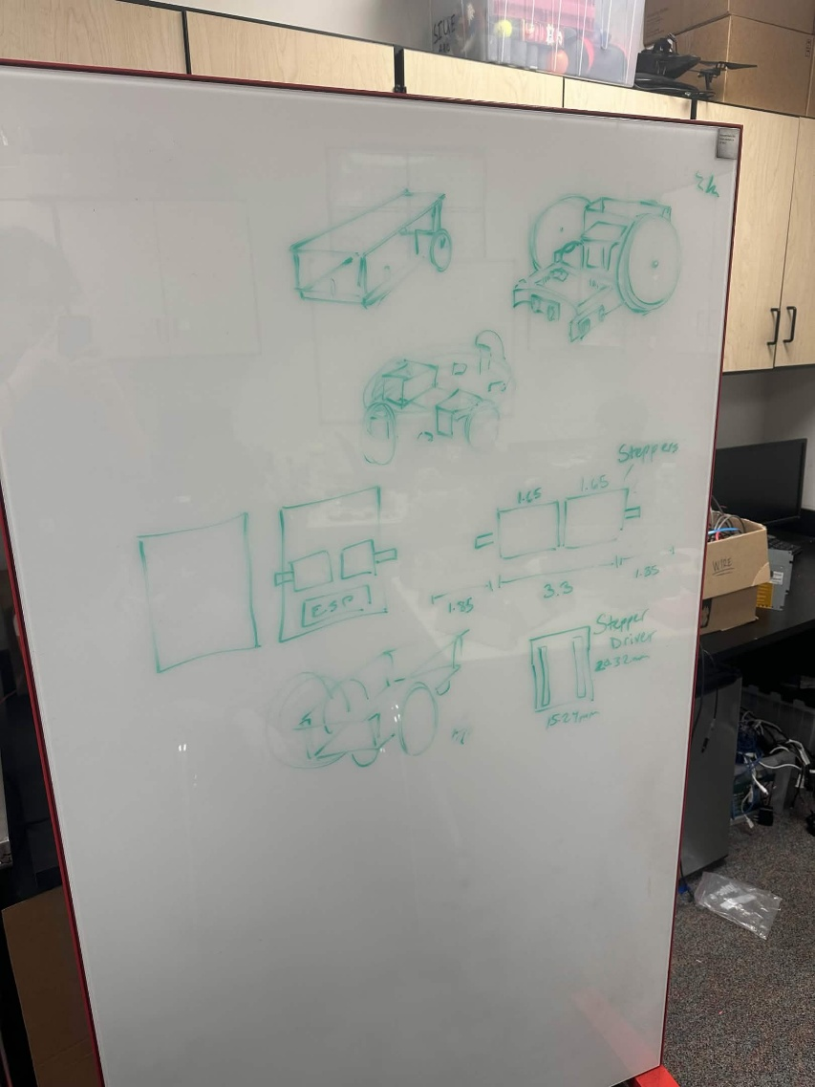
Our team wanted to start this year fresh with a new perspective on the micromouse competition, using the resources we had on hand to start from scratch and help newer members of the club get more familiar with the CAD software such as SolidWorks and Onshape. Our goal was to have a robot that would fit within the 7x7x7 inch size constraints that would leave ample room within the maze for proper turning and navigation while avoiding any unnecessary collisions.
Our team brainstormed various initial designs of the chassis and what we wanted the robot to look like, thinking of different shapes and sizes to fit the needs of the various electrical components we would be implementing this year. We took the different sizes of the motors as well as what kinds of sensors we would be using, making sure to measure out the proportions so that the design would fit within constraints.
Initially our team was opting for a single-level design, putting all of the components on one flat layer sticking the wheels in the back of the robot, but we decided to implement multiple levels of components that would not hinder the balance of the robot, attached together using thin poles at the four corners of the chassis. There were also ideas of robots with more than two wheels, implementing at least one in each cardinal direction to avoid the method of turning all together, but would require a lot more extra power and different mechanisms to make all four wheels function properly.
Figure 1: Initial Concept Brainstorming
After reviewing our initial concepts, our team decided to move forward with a stacked-platform design, making use of the vertical space for better communication between electrical components and controller boards without breaching the horizontal bounds of the size requirements. Each of the mechanical components and the final design will be explained further in the coming sections.
MOTOR CHOICE
One of the biggest choices our team had to make early on was the choice of motors that would control and drive the micromouse. The motors had to be small enough to fit back-to-back AND fit within the 7in limit, while also avoiding issues of drawing too much power from the rest of our system, preventing the need for additional batteries and weight on our robot. We also wanted to possess encoders for better motor communication, providing us with accurate feedback and tuning for better maze navigation and troubleshooting.
Our initial choice of motor was a small, 12V DC gear encoder motor with an output of 600RPM, which we found in our club storage. These motors would work great for fitting within size constraints, and the addition of the encoders helped our team to work on optimizing the control of the motors early on. However, the cheaper nature of these small motors revealed itself after a few club meetings, demonstrating poor stability of the motor shaft as well as loose and fragile wiring connections to the encoder, giving our team more problems than we were willing to troubleshoot throughout the design process.
Instead, our team was provided with two larger DC motors from our advisor, giving us a much better output with working encoders and a stabilized design, with the only caveat being the length of the motors. If the motors were fit flush against each other, the length of both motors combined with the wheels would be pushing the horizontal size constraints, making our team design around the full length when modeling the entire chassis. These motors were unlabeled, but still required a 12V source and worked the same with out respective motor controllers/
CHASSIS AND MOUNTS
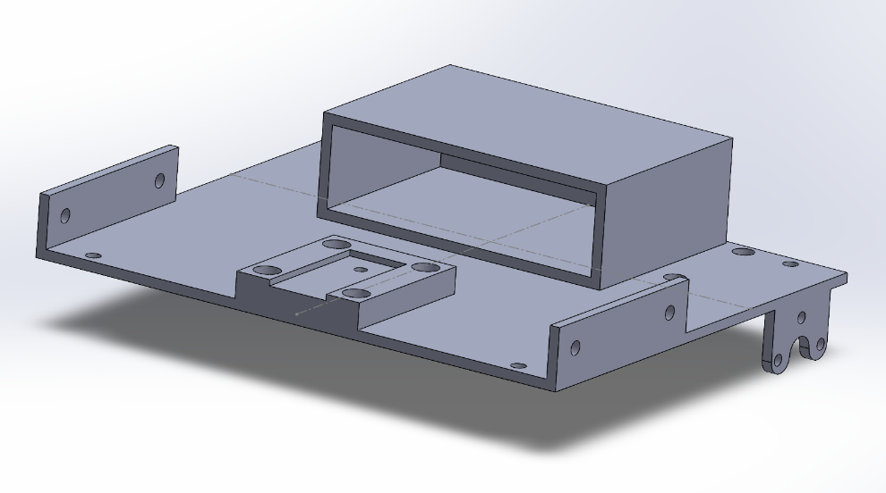
As stated before, our team wanted to opt for more vertical space for components this year, implementing a multi-leveled design for our CAD team to model and print. The idea behind the chassis design focused heavily on stacked rectangle platforms, in reference to a collection of small metal platforms we found in our storage (further mentioned in the iterations section). Choosing these shapes not only allowed for increased area for the placement of our main circuit and components, but also a clean and compact look to our micromouse. Wires and power would be able to pass through different gaps in each platform, condensing the connections of the each component to the inner chambers of the robot, preventing outside exposure and possible external conflicts.
Figure 2: Bottom layer of the chassis, includes sensor and motor mounts as well as battery housing
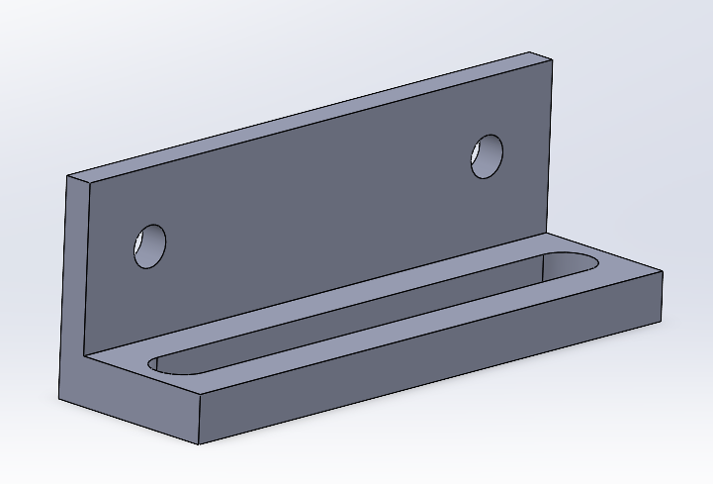
Our CAD team also worked hard to create the different mounts that would house the sensors and controller boards, making sure to properly measure the dimensions of each component to ensure a secure fit during assembly. We had our newer members practice modeling the different physical components of the micromouse, such as the necessary boards and the ball bearing, getting more practice with blocking out different components in a 3D space to better visualize a collective chassis. In addition, we also borrowed a Polulu Romi Chassis, implementing a simple and rounded design that could make for easy testing of our algorithms and motors if needed.
Figure 3: CAD model of a basic infrared sensor bracket
FINAL DESIGN
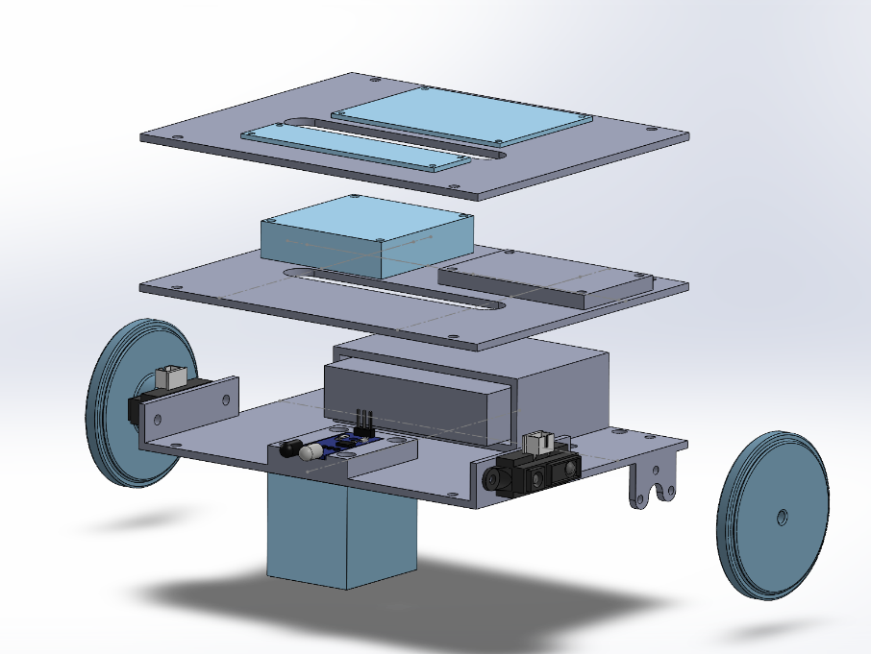
For the final design of the chassis in SolidWorks, the micromouse consisted of three different layers stacked atop one another, each layer housing multiple different components of the robot without feeling too cramped. The bottom layer consists of the main battery back slot, as well as the three sensors to detect the nearby surroundings. Each sensor mount was attached directly to the platform, with additional screw holes to allow for easy attachment. The second layer of the robot would house a PCB board and our main controller board, serving as the main hub for proper connections and communication. The top layer consists of another PCB board and the main motor controller, allowing for easy connection throughout the back of the robot without creating unnecessary wire organization.
Figure 4: Final CAD model of micromouse chassis in SolidWorks
A majority of the weight is placed on the bottom of the robot, taking care of proper alance as the micromouse starts and stops moving throughout the competition runtime. The almost box shape design also prevents the robot from easily tipping over, preventing unnecessary accidents and collisions with nearby walls. As mentioned, there are also slots in each platform to allow the connection of wires throughout the enclosed space.

ELECTRICAL
This section focuses on the electrical aspects of the robot, including the wiring, sensors, and controller boards. Detailed below are the different choices made by the team in how we wanted to organize and connect the different components of the robot, as well as our decisions regarding sensors and chosen outputs of the micromouse.
CONTROLLER BOARDS
As for the main “brain” of our micromouse, the team balanced between a few ideas and combinations based on which components we had in storage. Moving away from using Arduino boards due to individual preference, our team started using an ESP32 as our main controller that would handle the communication of various feedback. This board was not only compact and Bluetooth capable, but was also familiar to more club members, allowing for easier use and instruction when teaching the robot. As a controller board with similar capabilities to that of an Arduino MEGA and still having the number of pins needed for every component, our team decided that it was best to move forward with this design.
Since we only had so many ESP32 units in our possession and budget, another controller board that we used for our robot was the Pololu Romi 32U4 controller board, also discovered in our club storage. Mainly serving as a backup method if our main design fell through, this powerful board came included with built in motor controllers to communicate with its specified motors, saving us the extra trouble of tuning our individually store-bought choices. This board was also very large in size, taking up most of the room on the initial floor of our chassis, making it so the sensors would have to be elevated to the second level if the backup board were to be implemented. Furthermore, this board was not powerful enough to run our maze software on, needing the addition of a Raspberry PI board attached to the top pins to allow for communication and processing of the maze during operation. As this controller board was serving as unfamiliar territory for our members, I stress that this board served as a backup component due to its built-in capabilities, ensuring that our team got the most experience out of troubleshooting the various other components of the micromouse.
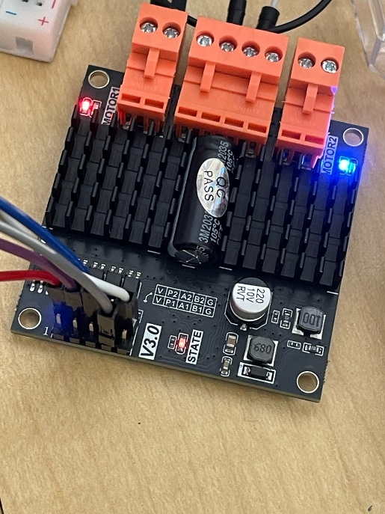
Lastly, our DC motors needed operation and communication through a motor controller board, of which our team tested two different options that both worked, leaving room to swap them out as needed. Our first and most familiar choice for most members of the team was the L298H motor driver, a dual H-bridge DC motor driver that has proved useful for controlling previous robots with DC motors. Use of this board would allow for simple power distribution and setup between the ESP32 and the two DC motors, with pin slots for splitting the power evenly for maximum performance. Our second choice was provided to use by our advisor, being the Dual-Channel DC Motor Driver, coming with two different motor channels for driving each motor simultaneously. This motor driver worked similarly to the L298H but had a larger dynamic adjustment range and power output, which helped to improve the quality of motor control and lead us to implement it in our main design.
Figure 5: Dual-Channel DC Motor Driver
SENSORS
Last year, our team focused on maze navigation using ultrasonic sensors, reading the various distances from each wall as feedback to then control the motors and communicate to our maze program where we needed to go next. This year, our team opted for infrared sensors, utilizing their smaller size as well as their faster detection and response time to further improve the responsiveness and efficiency of the micromouse. These alternatives proved to be helpful in immediate braking of the robot, as well as providing better real-time feedback to our maze-solving algorithm to help solve the mazes faster.
Our mouse consisted of three infrared sensors placed around the lowest level of our chassis, with two Sharp GP2Y0A21YK Infrared Proximity Sensors split between the left and right sides of our robot, and one REES52 Infrared Obstacle Avoidance Sensor on the front. Having two sensors on the sides of the robot helped with determining if our micromouse was surrounded by walls in the maze, giving it a better idea of where we were in our algorithm. The front sensor played a role in determining if our robot was about to run into a wall or not, giving the robot the protection against ramming into the maze walls and helping the robot to stop right away when moving too far. More detail about the communication and outputs of the sensors can be found in the programming section.

WIRING
For our team, ensuring proper connections and wiring for the micromouse was one of the biggest challenges we faced, with a large combination of crossing wires and railed connections giving us spots of trouble during our meetings. Our team wanted to ensure that no components would be damaged or overheated in the construction of each circuit, taking the time to carefully plan out and wire different components together while maintaining the safety of everyone’s electronics.
For power, our micromouse would run autonomously using a single 12V battery pack, where our team would need to figure out how to distribute this power between multiple motors, sensors, and a controller board. First, every wire had to be properly connected to the controller board, ensuring that the code could properly read the correct pins and guarantee an optimal performance throughout the maze. To power our ESP32 and smaller voltage sensors, we utilized a buck converter to step down the power to a manageable 5V output, avoiding damage to our sensors and “brain” of the robot. Other connections of the 12V power from the battery were distributed to the two DC motors using the motor controller board, providing the needed power for operation of both the motor itself and the built-in encoders.
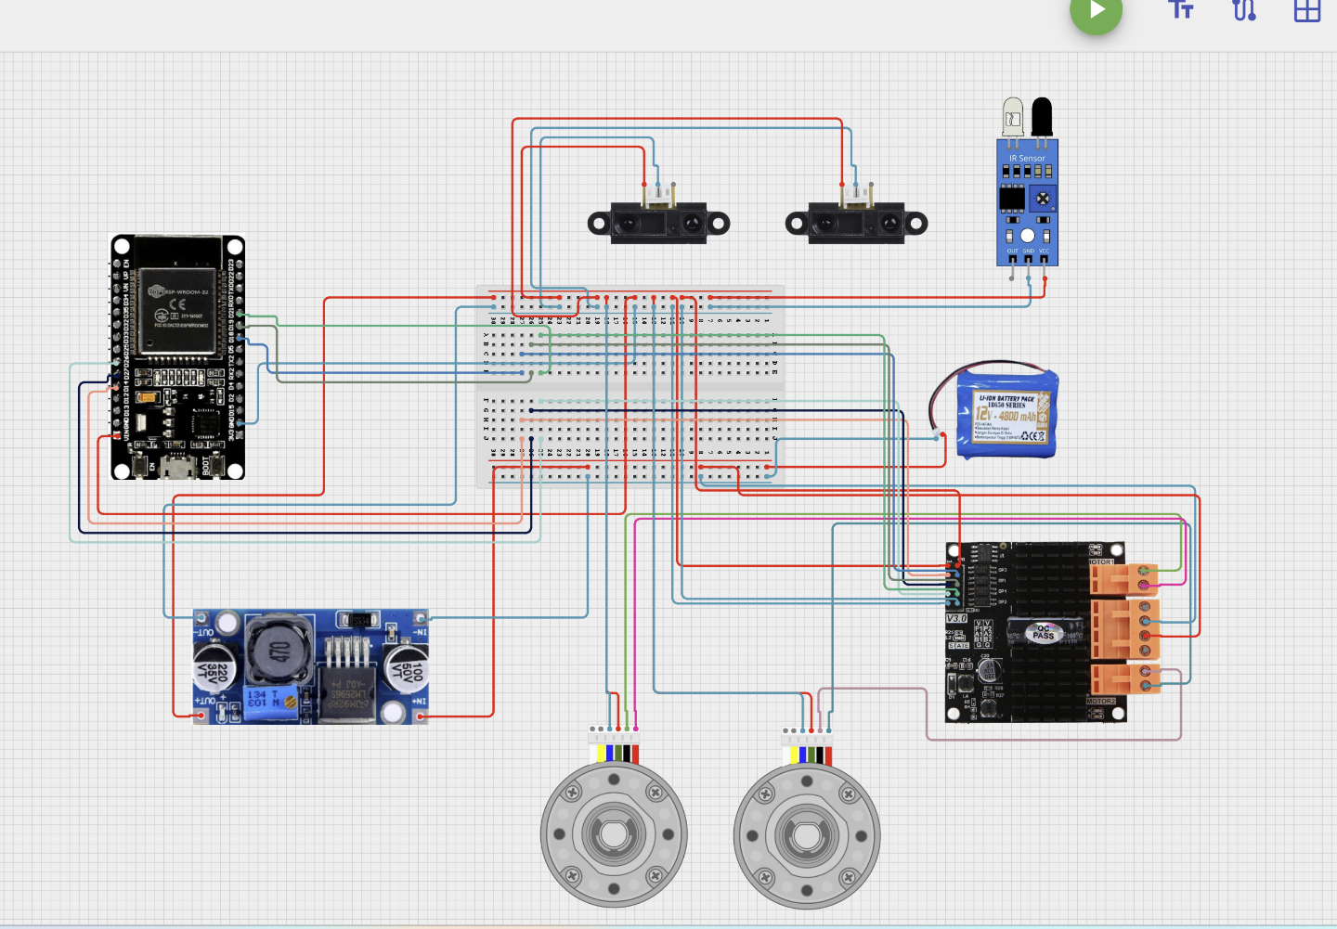
Figure 6: Micromouse electrical circuit diagram
To avoid the major challenges of wire disconnection and failure during the competition, our team opted to solder our main circuit onto a few PCB boards, allowing for more compact wiring and smoother communication between the components, giving team members an easier time with managing the system during testing. At least three of these boards were wired together and placed around the different levels of the system, crafted through the efforts of our team while allowing newer members to gain the experience needed with important engineering tools. Proper connections and power were properly labelled and planned out accordingly, avoiding accidents and injuries to fellow club members.
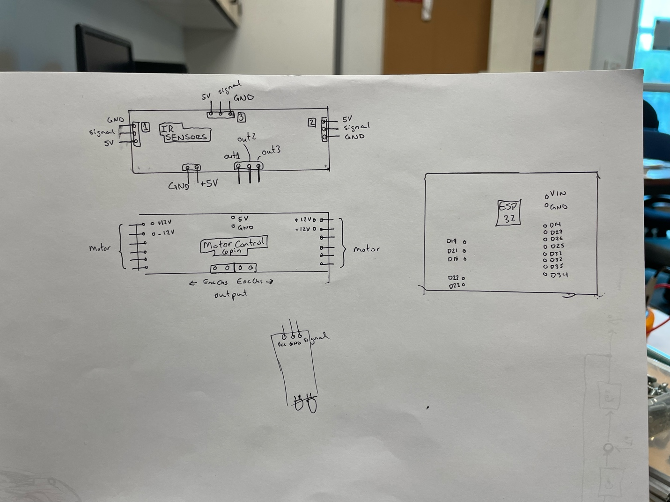
Figure 7: Planning of soldering connections and routes

PROGRAMMING
This section covers the programming and maze logic of the robot, such as what coding software was used and what functions were used to drive the micromouse. Detailed below are the steps we took to ensure the proper navigation of the robot, including communication between different components as well as the simulations and maze solving algorithms used.
MAZE SOLVING ALGORITHM
Our micromouse uses Flood Fill as its core algorithm — a form of Breadth-First Searching that works by "pouring water" from the goal back to the start, assigning distance values to each cell. The mouse always moves toward lower-value cells, driving it toward the goal. Maze solving is broken into three sequential phases (called our three-phase maze solver):
- Search Phase: The mouse explores the maze from the starting corner, continuously updating its internal map as new walls are discovered. Flood Fill is recalculated after each new wall is detected, always routing the mouse toward the goal via the best-known path.
- Return Phase: Once the goal is reached, the mouse navigates back to the starting position using the map it has built, again guided by Flood Fill.
- Goal Run: With a complete map in hand, the mouse executes a final optimized run from start to goal, following the shortest path determined during the search phase.
Our team decided that this was the best method for our mouse as it would suit all the proper needs of the competition, allowing for a concrete mapping of the maze as that could reproduce the fastest route to the end during runs following the initial search. This method of mapping out the maze also worked very well with the idea that we would have two infrared sensors on the sides and one sensor on the front, giving our robot the necessary tools to map out the maze and locate itself within its environment.
As for the simulations of the micromouse algorithm, we practiced our runs and navigation methods through a micromouse simulator, provided by user mackorone on GitHub, which allowed us to write and test maze-solving code that would present a diagram of our code working and solving a maze in real-time without a physical robot. The simulator would create a wall map using a 4-bit bitmask that would encode walls surrounding each cell, allowing for easy communication and recognition with the user’s provided inputs. Our programming team got the maze generator to randomly compile different mazes created by our team in the digital space, using our written simulation to tack position, potential crashes, and pass/fail reports based on simulation outcomes.
COMMUNICATION AND COMMANDS
The nomenclature and communication that are detailed in this section are in regard to the coding for the Pololu Romi and the Raspberry Pi controllers, as detailed by our logic team (See the ITERATIONS section, specifically MULTIPLE TEAMS – MULTIPLE ROBOTS). The main force that controlled our micromouse for this competition was the communication between the Romi 32U4 board, which handles all the low-level motor control and sensor reading, and the Raspberry Pi, which runs the navigation logic and issues commands. We opted for a Master-Slave communication because the Romi by itself did not have enough space for the complicated maze algorithm logic that we had implemented, leaving us to attach a Raspberry Pi as the external brain.
Half of the code for this project was completed in Arduino IDE, more specifically the Visual Studio application of the program. The system is split across two different components that communicate using I2C, hence the master-slave communication. Below you can see the struct data in which both sides of the connection needed to read and write to, indicating the individual directions and minor descriptions of their individual functions.
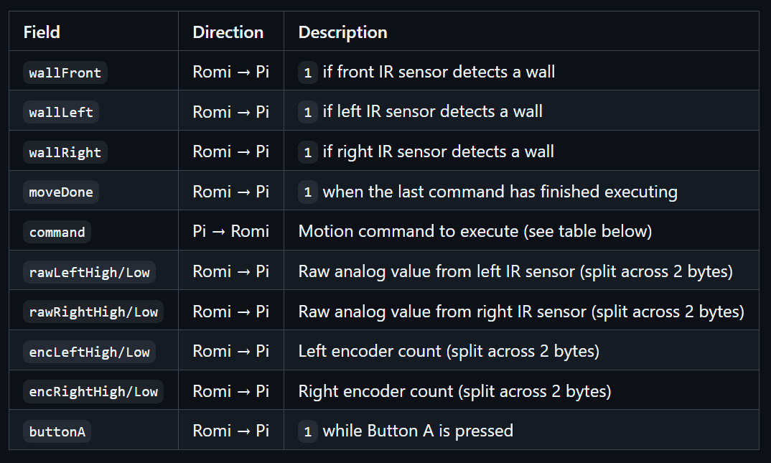
Figure 8: The different communications of the shared data buffer (struct data)
The Pololu Romi board handles the motion functions of the robot as well, including the encoder-driven motors that use a ramp-up -> cruise -> ramp-down speed profile to reduce any wheel slip or overshoot. We programmed a function called moveOneCell() that would drive the micromouse forward one maze cell, accounting for the 10” cells in the actual competition maze, which enforces encoder correction between both motor counts to allow the robot to drive straight. This function would also use proportional and damping gains to balance the analog IR sensor readings on both sides of the robot, using the nearby walls to center the robot in the corridor. During this entire process, the front IR sensor is checked at every step, ensuring that if a wall is detected mid-move, the robot would stop immediately instead of completing the cell to avoid collision and possible damage. Additional turn functions such as turnRight90() and turnRight180() were implemented to spin the robot in place using opposite motor directions until the encoder counts for each motor reached a target value, followed by a slight pause. The following table displays the turning constants that were utilized in our functions, making the best approximations of the encoder values as we can due to their sensitive nature.
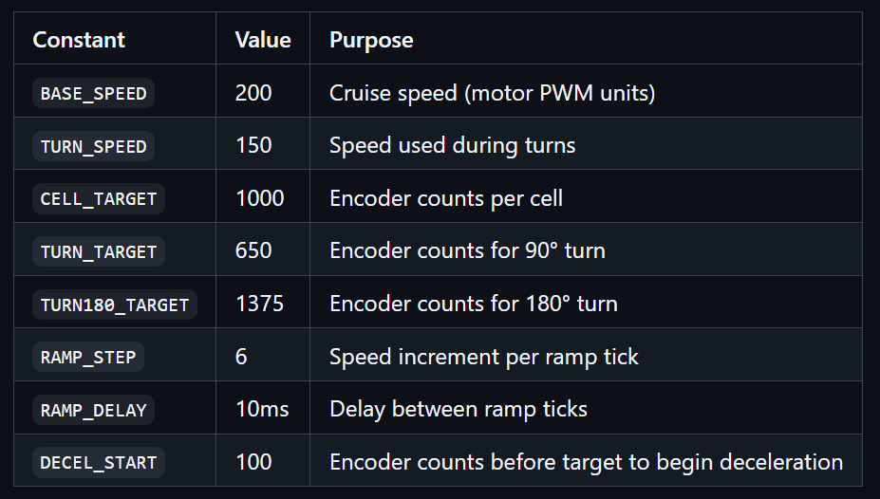
Figure 9: The different encoder values and constants used for our turning functions
The setup() function of the Romi code focused on initializing serial, configuring the front IR pin, starting the I2C slave at address 0x14, and waiting for the on button to be pressed before signaling that it is ready to move, giving the operator time to position the robot before accepting commands. The main loop() function continuously updates the shared buffer with fresh sensor and encoder readings, then checks for incoming commands. The robot does this until it receives a non-zero command, indicating that it is ready to move and can execute the move commands until stopped.
The Raspberry Pi board contained all the important information regarding the maze simulation, sending and analyzing the data received from the sensors to the Romi for smooth communication. This code was programmed in python, with our main maze.py file containing the navigation script, running a complete three-phase maze solver on the Pi and sending it to the Romi over I2C using the smbus2 library. Upon startup, this file would verify the connection to the Romi board, initialize the maze state and detect the initial heading from the IR sensor readings by reading the Romi buffer (14 bytes), wait for the on button to be pressed before starting, and then run the state machine loop until an interrupt or reaching the FINISHED state. As mentioned when talking about maze simulation, the Raspberry Pi uses a 4-bit bitmask to build a collection of digital walls/cells that the controller would then constantly update as the robot traverses, using our functions such as update_walls (s), and move_to_best_neighbor() to navigate and understand the current location. The solver program runs through four different states in sequence:
- SEARCHING: reads sensors, registers walls, re-runs flood fill, moves to the lowest-distance neighbor. Repeats until a goal cell is reached
- RETURNING: executes the pre-computed return path step by step back to (0,0). Tries a smart shortest route through visited cells first; falls back to reversing the exploration path if that fails.
- FAST_RUN: executes the pre-computed optimal path to the center without any sensor checks. Ends when a goal cell is entered.
- FINISHED: mission complete, prints final position, heading, cells visited, and phase reached.
The main flood fill code of the system assigns each cell from the wall map a distance value that represents the shortest number of moves to the nearest target given the currently known map. The flood_fill function will accept a visted_only flag that restricts the expansion to cells the robot has physically entered, used for return path and fast path computation to avoid routing through cells with unknown data. Below you can see an example snippet of our python code that represents the thinking of our robot. Again we should mention that this communication and code is for the Pololu Romi and Raspberry Pi communication, but the maze solving method can be transferred to the ESP32 and adjusted with the DC motor functions if necessary, as this section has explained the work our team has completed on our second robot after splitting the work into logic and motors (see ITERATIONS).

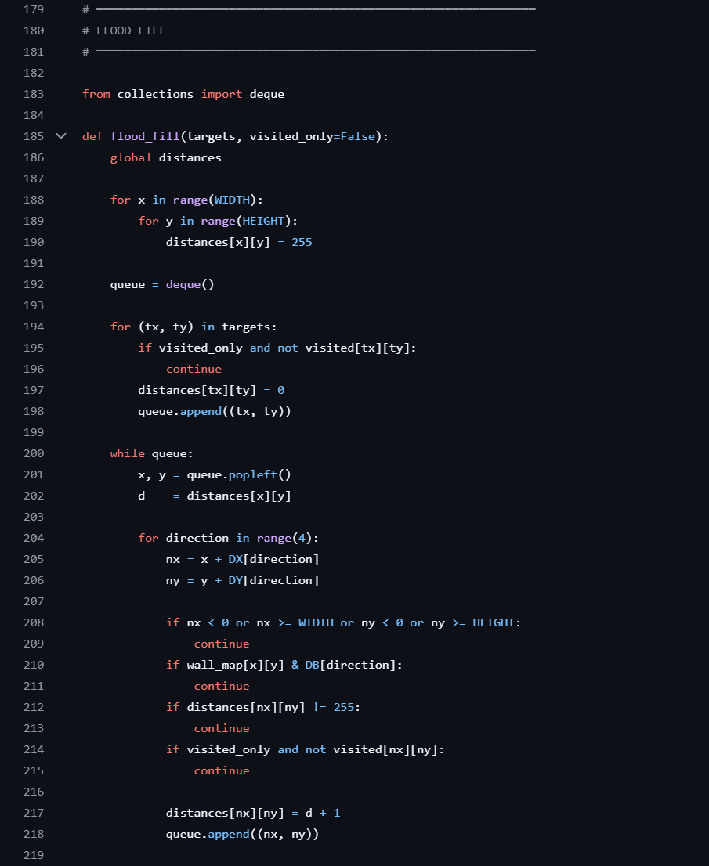
Figure 10: Example code from maze.py, involves the flood_fill section, which sheds light on the communication between the target values and the visited cells

ITERATIONS AND LIFECYCLE
EARLY ITERATIONS AND BEGINNINGS
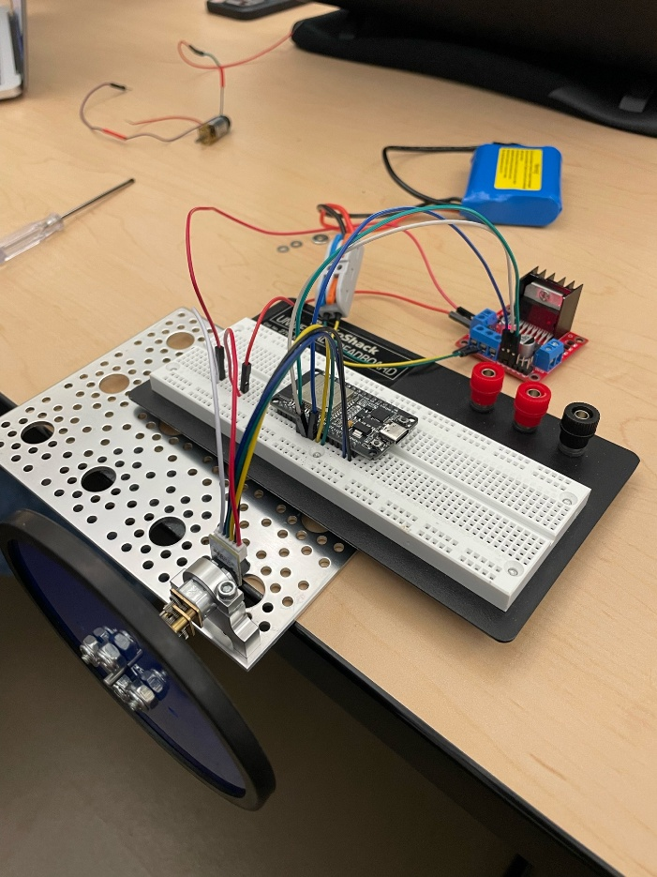
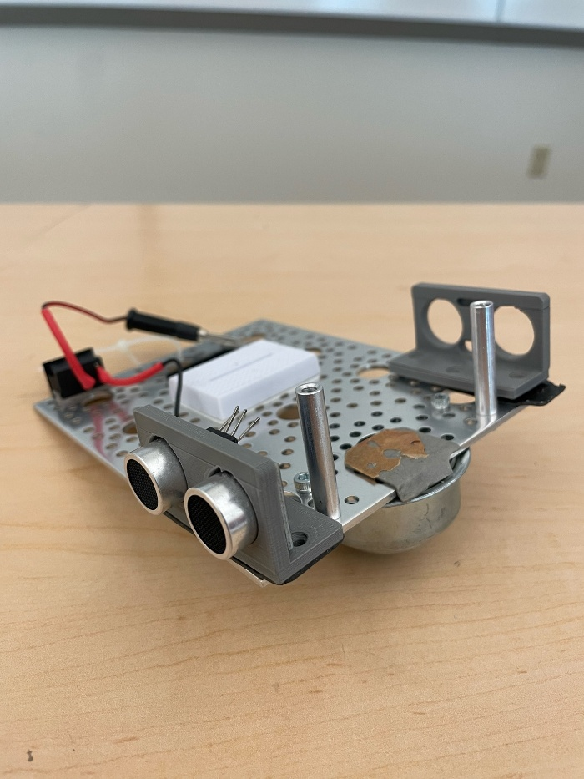
During the very first stages of our design and testing, our team worked hard to find components from our own club room that we could reallocate towards our new project, aiming to reduce costs as much as possible early on. We had already decided on some of the specific controller boards, such as an ESP32 and a L298H, to best handle some of the preliminary testing of our micromouse prototype. Seen on the left, we found a scrapped robot in one of our drawers that consisted of a large metal plate and a ball bearing, which we repurposed into our first testing of a basic motor circuit. By this point, we had already had some of our club members split off into a separate team to work on the maze-solving algorithm so it could be easily simulated and transferred onto the controller once the motors were tested and properly tuned. Using the very small DC motors mentioned in the electronics section and some spare wheels, we began to have some of our club members work on the initial measurements of the motor encoders, getting values to consistently reproduce movement commands.
Figure 12: First motor testing with small DC motors
Figure 11: Scrapped robot with metal plate
A lot of our first steps as a club were to get more members familiar with the project and what needed to be completed, allowing us to split tasks such as modeling and programming work between different collections of members. Many students were very eager to start working on different components of the micromouse, so we had members begin research on some of the best ways to complete the maze as well as encouraging brainstorming on how to implement stopping and turning functions for the robot.
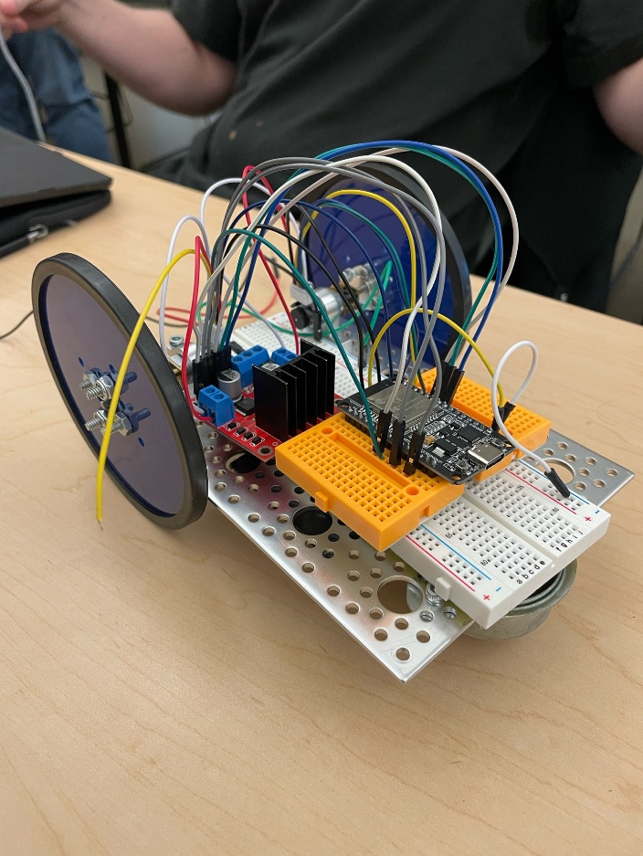
FIRST ITERATION AND TESTING
Figure 13: First assembly of micromouse
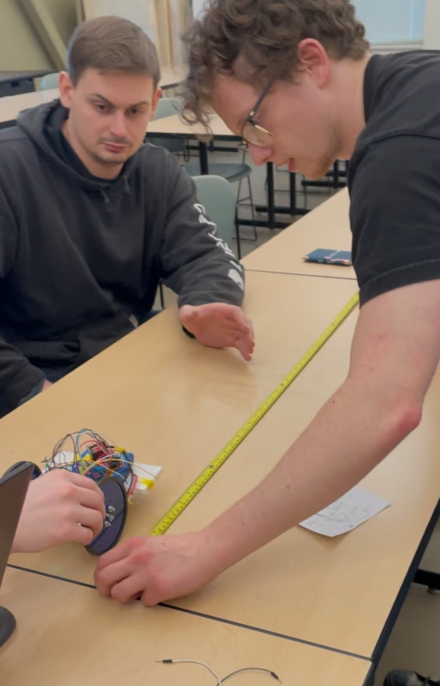
After combining the L298H motor driver, ESP32, and both small DC motors onto one rectangle frame, it was time to begin some initial testing of the robot by optimizing its straight-line pathing. Our goal was to work on getting the proper speed for the motors as well as determining if there was any left or right lean to the movement, helping us better plan our next steps. By this point we had three teams, one team spent their time working on the programming and tuning of the motors, one team worked on getting the infrared sensors to work and provide feasible values, and one team worked on modeling the different electrical components in SolidWorks to combine them all into one assembly for any final chassis design. In this vein, the infrared sensors were not yet attached to the robot, and most of the effort in meetings was working on properly powering our motors and tracking the encoder values. All the wiring for this first iteration was very loose, often requiring the team to rewire the components together every time we transported the micromouse between meetings, emphasizing the need for soldered connections later on.
Figure 14: Team works on optimizing straight-line pathing
We found pretty early on that there were initial problems in the encoder testing, giving our motor team a hard time due to the variation between speed of the motor and the projected value in the serial monitor. To work past this, our team started testing encoder values based on distance traveled to try and find a breakthrough constant that we could settle on. During this early phase our team also discussed different ways to implement braking mechanisms in our micromouse due to the slight overshoot the motors emiited when power was shut off. Some members even started to look into PID controller additions to the program to help reduce the overshoot and improve the communication between the two motors.
SECOND ITERATION AND SETBACKS
Only during the testing of our second iteration did we finally start to notice some of the setbacks that came with using older and cheaper equipment for testing. We noticed that some of the wiring that was attached to our smaller DC motor encoders was coming apart, and would no longer function properly even when soldered back together. Similarly, there was a slight wobble that arose in one of the motor shafts due to the cheaper nature of the product, which couldn’t be fixed through traditional means. In this sense, after constant work on the straight line pathing of the robot and tuning of the motors, we made the harder choice to abandon the further pursuit of the small DC motors due to their inefficiency and unreliability for the final micromouse.
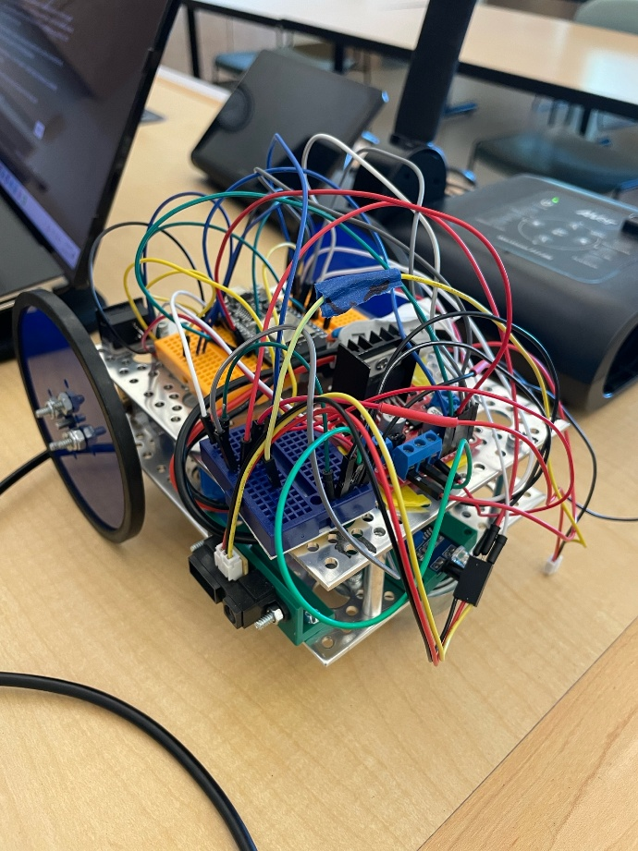
We took a step back as a team and began to re-evaluate how much time we had left before the competition and what we could get done. Luckily the sensors and CAD team were making steady progress in their respective departments, and we had about a month and a half to find new motors for testing and calibration. We also drafted out a rough schedule for the coming weeks, giving the team a better understanding of what needed to be completed by when. Our next focus was to find a new path to completion as well as getting a new rig ready for testing of the sensors and maze algorithm for final testing of the entire system. You can see in the attached photos that our micromouse was becoming a mass of wires at this stage, which helped us to start coming up with new ideas for wire organization and chassis design, which is where the third level of our final design comes from due to the crazy layout of our second iteration.
Figure 15: Second micromouse iteration
MULTIPLE TEAMS – MULTIPLE ROBOTS
Upon the completion of the final CAD model for the main chassis, our club decided that it would be best to split into two focused groups. One group would specialize in the optimization and analysis of our new DC motors provided by our advisor, working on the main chassis and the ESP32 controller to properly tune the movement and pathing of our final robot. The second group would specialize in the optimization of our infrared sensors and maze algorithm, using a different chassis and microcontroller as a foundation for the movement through the maze. The last month and a half of operations were split between these two groups, giving our teams two robots to work on, creating a situation in which we had a backup micromouse if one failed.
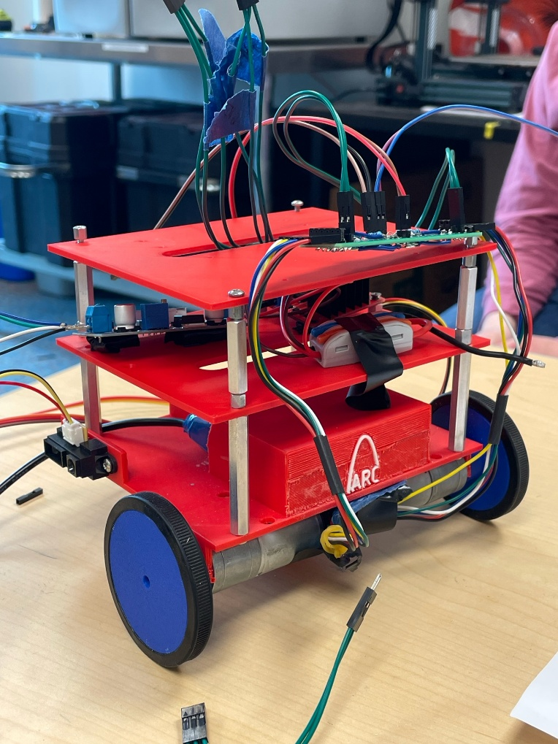
The first group maintained the path of the initial micromouse, focusing on the finishing touches of the main chassis and the new DC motors. This team specialized in focusing on the more mechanical side of this project, making sure the movement and assembly of the robot would be ready for the final combination with the maze logic team for final testing. This team used the new 3D printed chassis from our final design as a base, with the provided DC motors and ESP32 controller board as the main driving components. A majority of the time spent on this robot was used for figuring out the proper wiring for the robot and how we wanted it to connect throughout the different layers, plotting out the design of the main circuit attached to the PCB boards. This team also helped us identify if there were different problems with the CAD model of the final design in practice, such as the weight of different components and the fitting size of each mount. We wanted to make sure that the new DC motors were functioning properly, and the team got to work on troubleshooting the different turn functions and encoder values of the robot so they could be easily implemented into the maze logic. Through the work with this variation of the micromouse, we found out that having the battery pack on the back of the robot created too much weight, leading to the entire robot tilting backwards when powering the motors and taking the front ball bearing off the ground. Therefore, we not only changed to a different battery location in the middle of the bottom platform, but we opted to use a different ball bearing to also help our micromouse gain more traction upon traversal.
Figure 16: Final chassis design printed with mounted components and boards
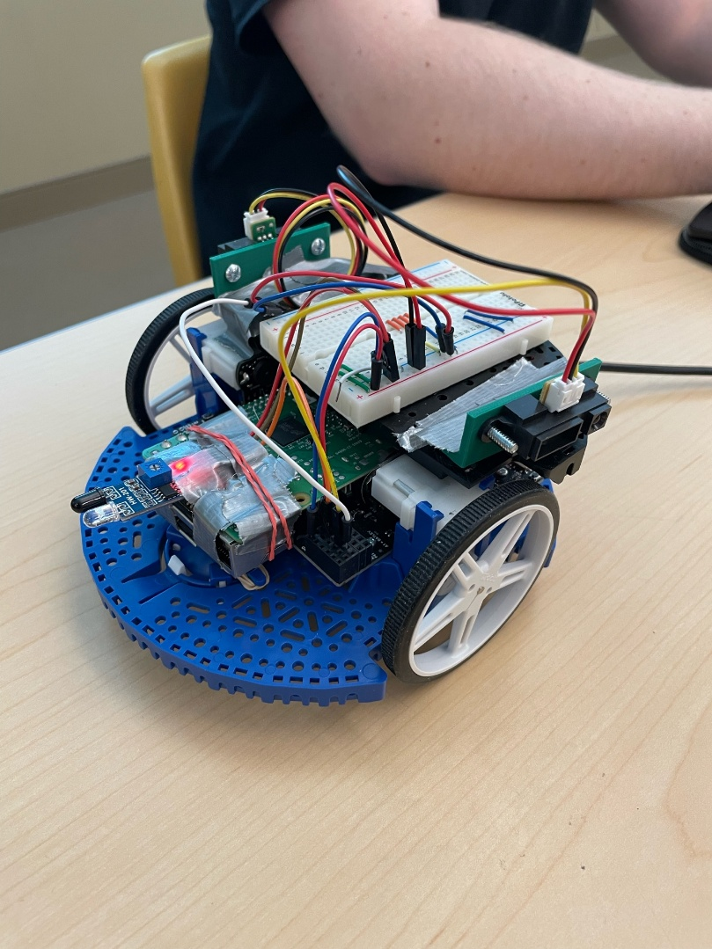
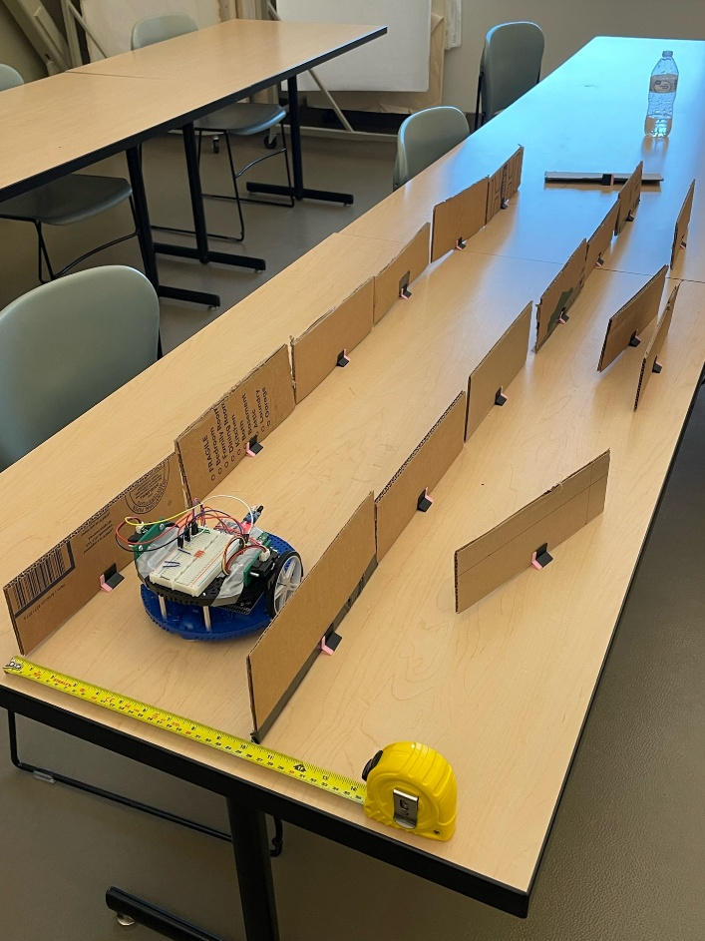
The second group focused on getting the infrared sensors and maze logic to communicate properly as the micromouse navigated the maze, making sure the programming side of the robot would be ready for combination with our main chassis and motors. For movement and simulation, this team adopted a new chassis and controller board for testing, the Pololu Romi 32U4 and its complimentary Romi Chassis. Found in our club storage, this controller board and chassis came with its own small motors and controller boards to serve as a foundation similar to our own design. While the chassis itself is not our original design, it is only a custom shell that came with the Romi controller board to properly carry the large board and its power source. All of the work done on this additional robot is our ORIGINAL efforts, including the wiring, programming, tuning, and simulation, and this is NOT to be confused with a micromouse kit. Our team has greatly modified the controller board and the chassis, adding our own components and even attaching a Raspberry PI to the main chassis for additional storage for the maze solving logic.
Figure 17: Pololu Romi and Chassis used by the logic team
Figure 11: Secondary model practicing in custom cardboard maze/lane setups
Additionally, this strong foundation allowed our logic team to optimize maze traversal with our infrared sensors, giving our programmers a chance to make the code easily transferable between the Pololu Romi and the ESP32, given a few re-arrangements with motor functions within the code. To test this second robot, the team cut out and constructed many 10” cardboard walls to simulate the environment of the competition maze, with small 3D-printed stands allowing for easily rearrangeable situations in which we could test the maze plotting. These physical simulations helped our teams perfect movements through L-shaped corridors, identify dead-ends, and even navigate back to the start of the maze upon completion. There was continued work on allowing the robot to straighten itself within the lanes of the maze, while also working on stopping the robot if it overshot its consistent 10” movement patterns towards a wall. Through this testing in cardboard mazes, our logic team got our robot to properly navigate mazes autonomously, leading to our final decisions regarding the competition.
FINAL DECISIONS AND REMARKS
During the final days before leaving for the competition, our sensor and logic team was very successful in implementing the necessary movement commands and maze solving algorithms, resulting in our strongest performing robot. The mechanical team was not as fortunate, however, with last-minute problems surfacing in the wiring department, leaving the teams with insufficient time to properly transfer the solving code onto our main chassis. With this in mind, our team started to shift our full attention to the Pololu Romi and Raspberry Pi setup, working to optimize the pathing in time for competition. We worked to the very last minute in finalizing and designing our main chassis and system, but our expectations were not met in terms of performance and we had to opt for our backup choice, which was a heavy blow to the team.
Even though the main design will not be serving as our competition representative, it gives our team a fresh perspective into the ups and downs of the design process and what steps can be taken to improve. The performance and design of our secondary entry are still the results of a hard-working collection of students and engineers, and we experienced a lot of valuable lessons these past few months. Our club members gained a lot of experience in CAD and wiring, learning more about how to solder and design connections as well as troubleshooting complicated code and debugging faulty equipment. We hope that many can learn from the results of our team’s efforts this year, and that our work as a club can help elevate us all as future engineers.

CLUB MEETING SUMMARIES
Wednesday Meeting | 2/25/2026
- Objective: Start on PD control for wheel motors; Modeling our chassis using CAD
- Notes: Club members split into two teams, one team spent their time working on getting the temporary mouse assembly to go straight by tuning individual motor speeds, while the other team worked on modelling different components in SolidWorks while teaching some of our newer members the basics of CAD.
- Challenges: There have been issues working with powering of our motors, with concern over wrong wiring or voltage distribution resulting in the increased temperature of the ESP32 board. Conversations rose about how to bring our robot to a stop, talking about possible braking mechanisms, motor direction, and motor control
Friday Meeting | 2/27/2026
- Objective: Integrating infrared sensors; Modeling the chassis using CAD; Coding 90/180° turns
- Notes: Members split into multiple groups, improving individual CAD skills by modeling different components of the mouse prototype such as the IR sensor mounts, wheels, and baseplates. Lots of work on organizing GitHub files and getting members familiar with where certain folders are located. Programmers worked on creating different functions for turning a certain number of degrees, working on getting the motors to replicate specific corner turns.
- Challenges: Provided IR sensors are not working at full capacity, discussion about switching back to ultrasonic or buying new sensors. Problems with acquiring ESP32 libraries on certain computers for coding.
Wednesday Meeting | 3/4/2026
- Objective: Modeling different assembly components; Coding and combining different programs for encoder count.
- Notes: Members worked on testing different programs that were coded in-between meetings. Working on determining different methods of displaying encoder counts and optimizing turn programs, continued work on straight movement control. Splitting CAD challenges between newer members to work on different components for the final assembly while improving modeling skills.
- Challenges: N/A
Friday Meeting | 3/6/2026
- Objective: Focus on mounting newly printed IR sensors onto the chassis and starting work on PID control for motors
- Notes: Team continues work on modeling full chassis in solidworks with different mounts, while individuals focused on properly hooking up the IR sensors to the ESP32 for testing with written code. Some members worked on constructing block diagrams for PID control for easier visualization of the control circuit.
- Challenges: There were issues with lack of ports on the ESP32, working around common ground wiring. Started taking apart the two-level chassis to place the components on one level for easier access.
Wednesday Meeting | 3/18/2026
- Objective: Working on testing wheel encoder accuracy, straight path calibration, and turn function consistency.
- Notes: Team worked on optimizing the robot controller and the functions that correlated to the turning, looking over methods that made the turn functions more consistent for competition level accuracy.
- Challenges:
Friday Meeting | 3/20/2026
- Objective: Get familiar with new schedule and next steps
- Notes: Team began working with a new schedule, focusing on new aspects of the motors as well as working with the new motor controller. Members split up to work on modelling new components in CAD to start working on the new chassis while other members started working on testing sensors and implementing speed control on motors.
- Challenges: N/A
Wednesday Meeting | 3/25/2026
- Objective: Make new code and adjust for new motors. Begin sensor integration
- Notes: Starting with two different robots, one for sensor work and one for motor tuning. Success with sensor integration, working on getting feedback for L hallway simulations.
- Challenges: Still waiting for chassis to print, wiring problems on current design delay work on motor tuning.
Friday Meeting | 3/27/2026
- Objective: Working on increasing straight line pathing. Continued work on sensor integration
- Notes: Teaching new members more about the soldering communications and what connections are necessary for our proto board construction.
- Challenges: Sensor robot ran out of battery, need to recharge prevented further progress during the meeting. The front of the robot has started to leave the ground during initial start time, leading the team to start working on revisions for better weight control instead of having the battery on the back of the robot.
Wednesday Meeting | 4/1/2026
- Objective: Continued work on increasing motor optimization and mapping logic implementation
- Notes: The CAD team continues work on making a newer, optimized chassis by moving the battery to the bottom of the micromouse for better weight distribution.
- Challenges: There were initial struggles with the final robot in the wiring of our ESP32, with the robot seemingly facing errors where it didn’t before, leaving the team stuck rewiring the chassis from the ground up. The maze logic team continues to struggle with the infrared sensors, leading to new purchases to avoid faulty devices during execution.
Friday Meeting | 4/3/2026
- Objective: Continued work on increasing motor optimization and mapping logic, working on finalizing robots for competition and beginning final testing
- Notes: As the team nears competition, we focused our efforts on getting our robot up and running to begin testing, making sure that it is in the best condition possible when we leave, the team worked diligently on solving minor wiring problems and continuing to simulate mazes with cardboard walls.
- Challenges: Motor controller board is giving team problems, device is receiving the correct voltage but is not receiving any amperage, where the board is failing to activate any LED’s or the motors. Team spent the time to identify any potential faulty components on the board in hopes of avoiding the purchase of a new one.
Wednesday Meeting | 4/8/2026
- Objective: Continued work on getting the final robot up and running, focusing on polishing some of the lane centering and turning functionality.
- Notes: As the team started to near the dates of the competition, we wanted to make sure that all our bases were covered so that the micromouse would run smoothly when needed. Our sensor team spent a lot of time refining the mapping of the maze in the controller as well as making sure the robot wouldn’t crash into any walls during the competition. Our motor team worked on finishing some of the final soldering for the PCB boards and then putting it all together on the final chassis.
- Challenges: The micromouse seemed to be swerving into the right wall when testing some of the lane centering functions, some additional work needed to be completed before application in the field.

